Project Design Phase-II
Data Flow Diagram & User Stories

Date | 1 November 2026
Team ID
Project Name | EV Market Performance & Insights Platform
Maximum Marks | 4 Marks

Data Flow Diagrams:
A Data Flow Diagram (DFD) is a traditional visual representation of the information flows within a system. A neat and clear DFD can depict the right amount of the system requirement graphically. It shows how data enters and leaves the system, what changes the information, and where data is stored.
DFD Symbol Legend
Symbol | Name | Description
Oval / Rounded  shape | External Entity | A person, organization, or system outside the project that sends or receives data (e.g., Customer, Payment Gateway).
Rectangle with  numbered header | Process | An activity that transforms incoming data into outgoing data (e.g., Validate Request, Process Order).
Rectangle (solid fill, no number) | Data Store | A place where data is held for later use (e.g., Customer Database, Inventory).
Labeled arrow | Data Flow | The movement of data between entities, processes, and data stores, labeled with what data is being passed.

Example: DFD Level 0 (Industry Standard)

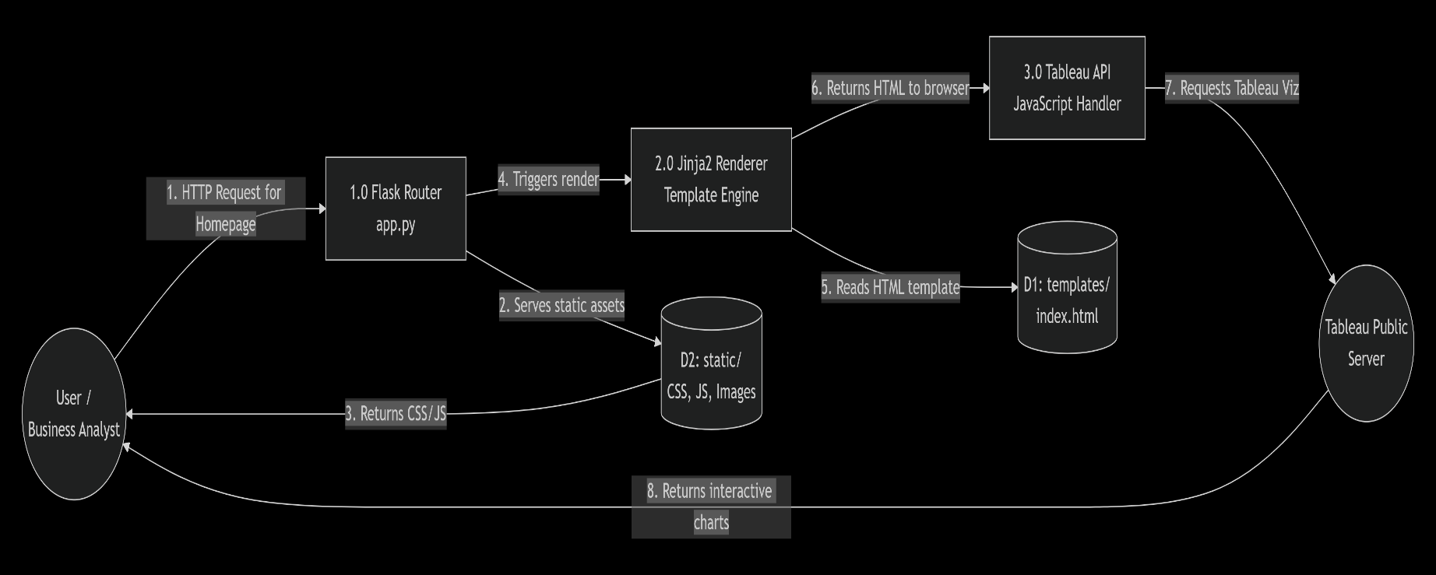

User Stories
Use the below template to list all the user stories for the product.
User Type | Functional Requirement (Epic) | User Story Number | User Story / Task | Acceptance criteria | Priority | Release
Business Analyst | Dashboard Access | USN-1 | As a user, I want to view the EV market dashboard immediately on the homepage so that I can see high-level KPIs. | User can see the Tableau dashboard loaded without scrolling past the hero section. | High | Sprint-1
Business Analyst | Interactive Filtering | USN-2 | As a user, I want to filter the data by region and year so that I can analyze specific markets. | Dashboard updates dynamically when regional or year filters are changed. | High | Sprint-1
Strategic Researcher | Historical Context | USN-3 | As a researcher, I want to view the Tableau Story so that I understand the chronological timeline of EV adoption. | User can navigate back and forth through the Story steps using Tableau navigation buttons. | Medium | Sprint-2
General User | Navigation | USN-4 | As a web visitor, I want a responsive navigation bar so I can jump to the Dashboard, Story, or Contact section easily. | Clicking links scrolls the page smoothly to the correct section on both mobile and desktop. | Medium | Sprint-1
Developer | Asset Routing | USN-5 | As a developer, I want Flask to correctly serve static CSS/JS files so that the layout doesn't break. | Browser console shows HTTP 200 OK for all static/ assets. | High | Sprint-1
Developer | Environment | USN-6 | As a developer, I want to run the Flask app locally with Debug mode enabled so I can test changes. | App runs on 127.0.0.1:5000 and auto-reloads on file save. | High | Sprint-1

